G/EPON Fiber Optic Access Terminal

Equipment 1GE XPON ONU
User's Guide

Contents
G/EPON Fiber Optic Access Terminal I
Equipment 1GE XPON ONU I
1 Note 1
1.1 Installation Precautions 1
1.2 Precautions for use 1
2 Introduction 2
2.1 Product characteristics 2
2.2 Product specifications 3
3 Log in to the web management page 3
4 Management page description 5
4.1 Device 5
4.2 PON 6
4.3 LAN 8
4.4 Settings 8
4.5 Vlan Settings 9
4.6 Commit/Reboot 9
4.7 Reboot Timer 10
4.8 Multi-lingual Settings 10
4.9 Backup/Restore 11
4.10 Password 11
4.11 Firmware Upgrade 12
4.12 Logout 13
4.13 Statistics 13
5 Common Fault Handling 14

Note

Installation Precautions
① Do not place the device near flammable or conductive materials,
in high temperatures (such as direct sunlight) or damp environments, or on PC chassis, and check if other household appliances are placed stably in the surrounding area.
② Check the cables for signs of aging.
③ Unless approved by the manufacturer, please use the type of power supply indicated on the label and the adapter included with the product.
④ To prevent lightning damage to the product, ensure that the ground end of the power outlet and power adapter is safely grounded,Be sure to unplug the power supply and all wiring of the equipment during thunderstorms.
⑤ The input voltage fluctuation of the device must be less than 10%, and the power plug should not be used in the same socket as the refrigerator, hair dryer, or electric iron.
⑥ To avoid electric shock or fire caused by overload of the power socket, damage to the wire body, or damage to the plug, please regularly check the power cord. If damage is found, please replace it immediately.
⑦ Items cannot be placed on the device.

Precautions for use
① Before using the device, please carefully read the user manual and follow all precautions on the user manual and product.
② Avoid direct eye contact with the optical interface to prevent laser radiation emitted by the interface from damaging the eyes. Please try to wear safety glasses as much as possible to effectively protect your eyes from damage. It is best to insert a fiber optic interface sheath when the optical interface is not in use.
③ Turn off the power when not using the device.
④ To ensure safety, do not open the casing of the device without authorization, especially when the device is powered on.
⑤ Before cleaning the equipment, unplug the power supply. Use a soft, dry cloth to clean the equipment and avoid using liquids or sprays.

⑥ Unless instructed by our customer engineer or your broadband supplier, do not connect this product to any electronic product, as any incorrect connection may cause power or fire hazards.

Introduction
1GE ONU is a passive optical network user end product launched by our company for the broadband access market based on GPON/EPON technology. ONU is used in conjunction with GPON/EPON office end products (OLTs) to provide users with a complete broadband access solution based on GPON/EPON technology.
GPON/EPON technology is an emerging technology that combines the advantages of PON technology and Ethernet technology, and is a point to multipoint networking technology. The OLT devices at the office end are interconnected with multiple ONU devices through a passive optical network in the middle, and combined with single fiber bidirectional technology, the GPON system can use very little fiber resources to meet the multi user access needs of operators.
The technical performance meets the requirements of ITU-TG.984, IEEE802.3ah, China Telecom GPON Equipment Technical Requirements (V3.0), China Telecom EPON Equipment Technical Requirements (V3.0), and other specifications. It has good compatibility when used in conjunction with mainstream manufacturers' office end OLTs. The device supports a symmetric 1Gbps transmission rate for both uplink and downlink, providing users with good QOS guarantee, flexible bandwidth allocation of Ethernet services, and IP comprehensive services.

Product characteristics
PON interface
Standard: GPON/EPON interface, meeting ITU-T G.984 and IEEE802.3ah standards
Connector: SC/PC interface
Transmission distance: 20 km
Uplink and downlink 1.244Gbps/2.488Gbps (GPON), 1.244Gbps/1.244Gbps (EPON) Transmission rate split ratio 1:128 (GPON), 1:64 (EPON)
Support optical power detection
Ethernet interface
Standard: Meets IEEE 802.3/802.3u standard
Connector: RJ45
Working mode: supports full-duplex and half-duplex, supports 10Base-TX, 100Base-TX, 1000Base-TX

    - Fully compatible with ITU-T G.984.x, IEEE802.3ah standards
    - Support VLAN configuration
    - Supports Ethernet line performance statistics function
    - Support ONU automatic discovery, link detection, and remote upgrade
    - Support power-off alarm
    - Support Qos configuration
    - Support firewall settings

Product specifications

Ambient temperature: 0°C～60°C
Relative humidity: 5% to 95% (non-condensing)
Power consumption and power supply: <10W, 12V/0.5A
Indicator light description:
name | colour | describe | working status
name | colour | describe | Light always on | The light goes out | light flashing
Power | green | Power Indicator | Device is powered | Device is not powered
LOS | red+green | optical signal |  | Optical signal input is normal | No light signal input  Or the light signal  input is abnormal
PON | green | Registration indicator light | registration success | No optical signal input or  registration failed | Registering
LAN | green | Connection indicator light | Ethernet connection is normal | Ethernet not connected | Ethernet port with  data transmission

Log in to the web management page
- Manually set the local network port IP address of the computer to 192.168.1.100

② Use a network cable to connect the computer to any Ethernet port on the ONU
③ Open a browser to access http://192.168.1.1 (User: admin, Password: admin)
After successful login, the page is as follows:
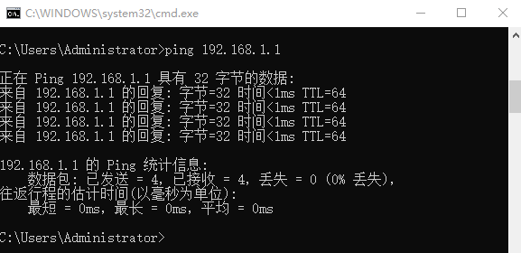
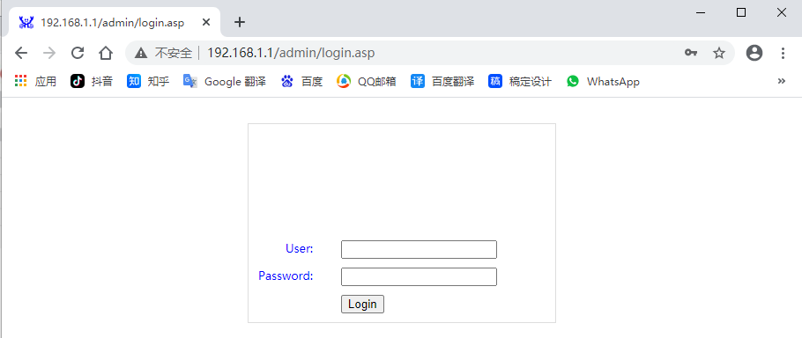
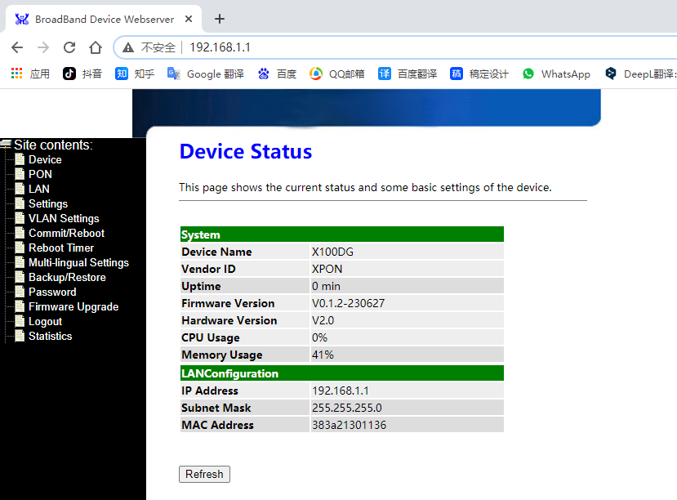

Management page description
Management pages include:Device、PON、Settings、VLAN Settings、Commit/Reboot、Reboot Timer、Multi-lingual Setting、Backup/Restore、Password、Firmware Upgrade、Logout、Statistics

Device
On this page, you can view information such as device name, manufacturer ID, uptime, software and hardware versions, CPU usage, LAN IP address.

PON
The this page can view PON status, registration status, GPON status (or EPON status)
4.2.1 GPON registration page
GPON registration success status: ONU status is stable at 05, as shown below
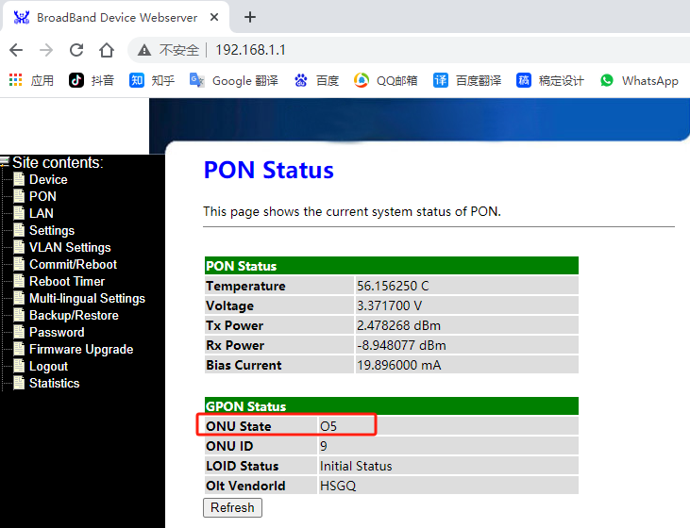

4.2.2 EPON registration page
EPON registration success status: ONU status is stable at 01，as shown below
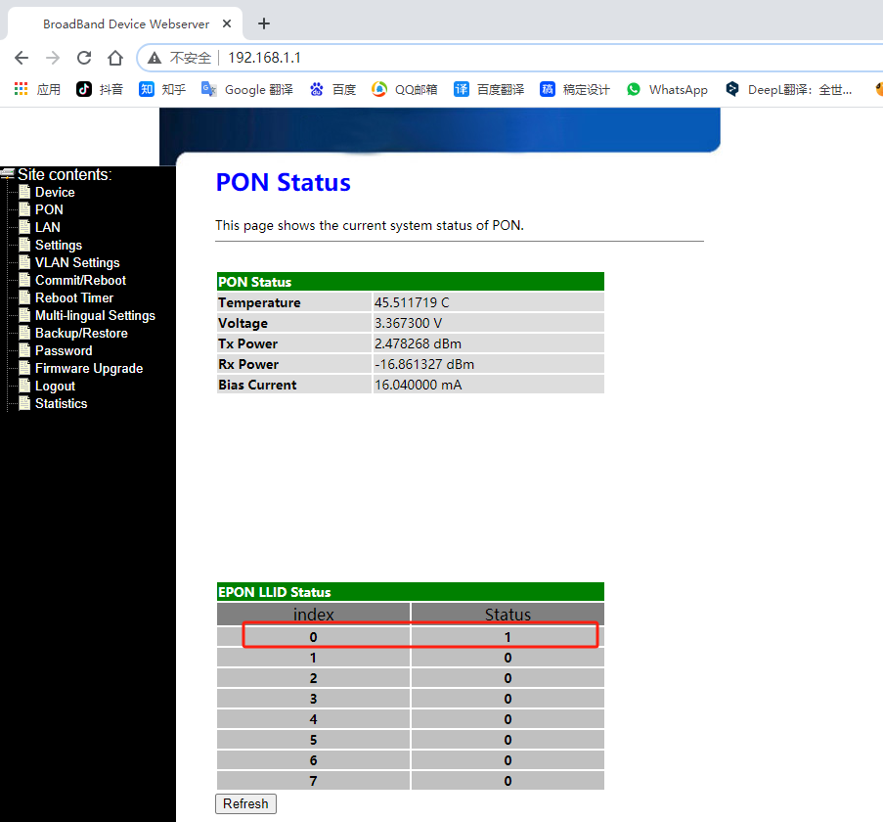

LAN
On this page, you can see the ONU LAN IP (the IP used to access the ONU web page), and you can modify the IP address.
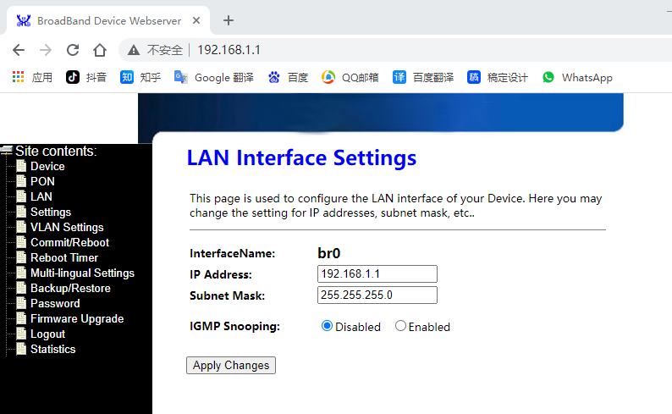

Settings
On this page, you can fill in/modify LOID, PASSWORD, PLOAM and GPON SN to register the ONU on the OLT.
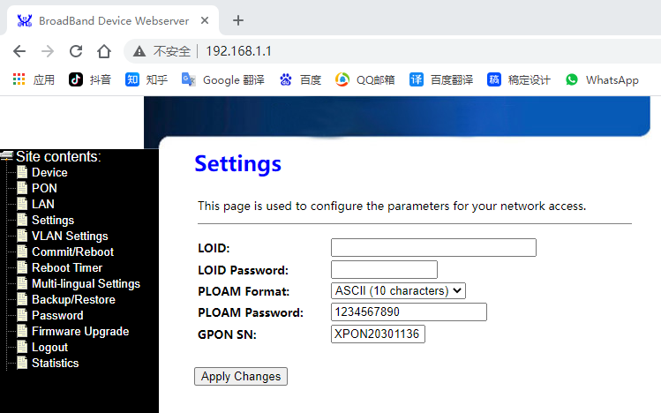

Vlan Settings
On this page, VLAN can be set, and there are transparent mode(transparent transmission of all VALNs) and PVID mode in manual configuration
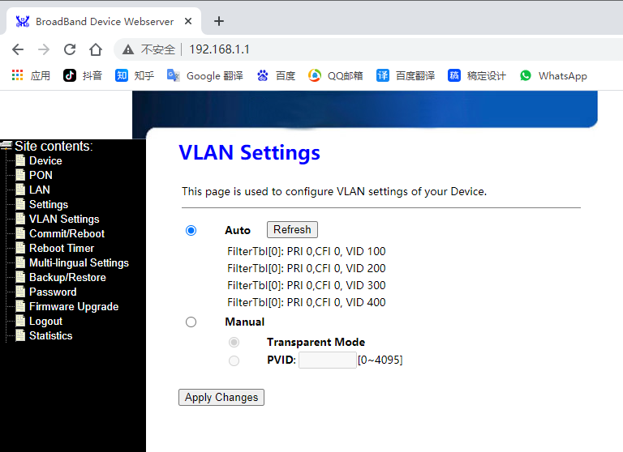

Commit/Reboot
On this page, you can save the current configuration and restart the device
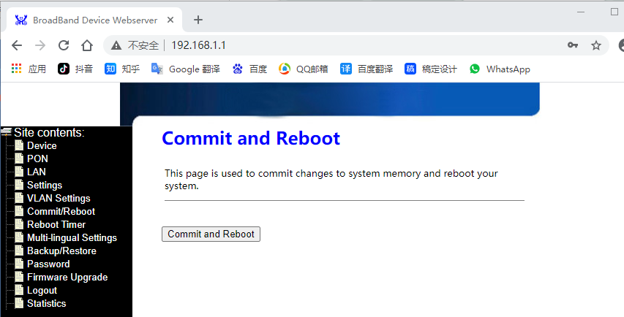

Reboot Timer
On this page, it is possible to set a timed ONU restart, in minutes
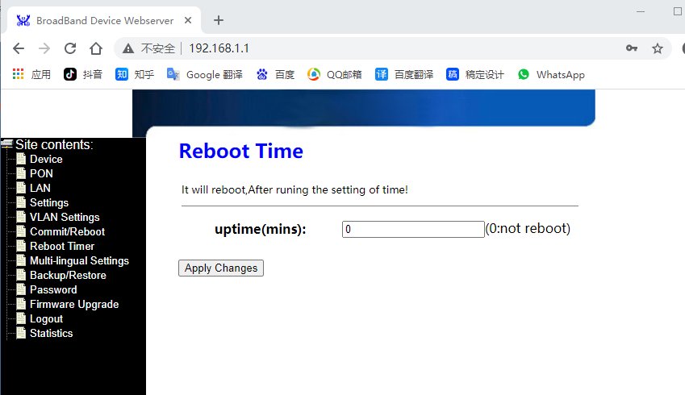

Multi-lingual Settings
On this page you can set the language of the web page (Chinese/English)
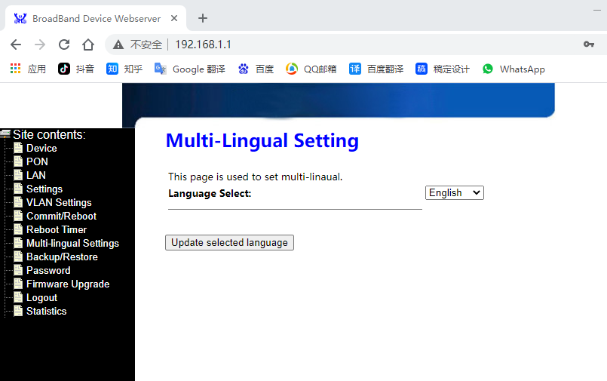

Backup/Restore
①Backup Settings to file: Back up and export the configuration document of the current device
②Restore Settings from file: Import profile restore configuration
③Reset Settings to default : Restore ONU to factory default configuration
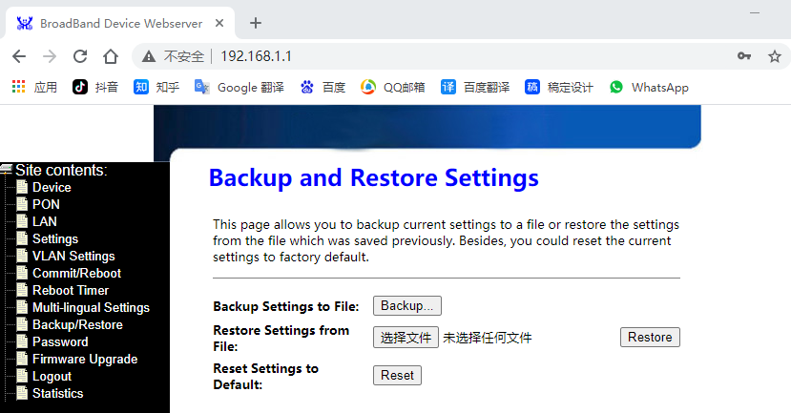

Password
On this page, you can modify the user and password of super administrators and regular users
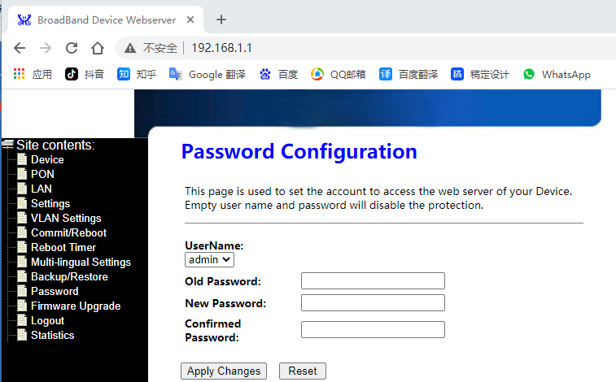

Firmware Upgrade
On this page, you can upgrade the version of ONU
Operating Steps：Click "选择文件", select the upgrade package (. tar package), click "Upgrade", and the upgrade progress bar will appear
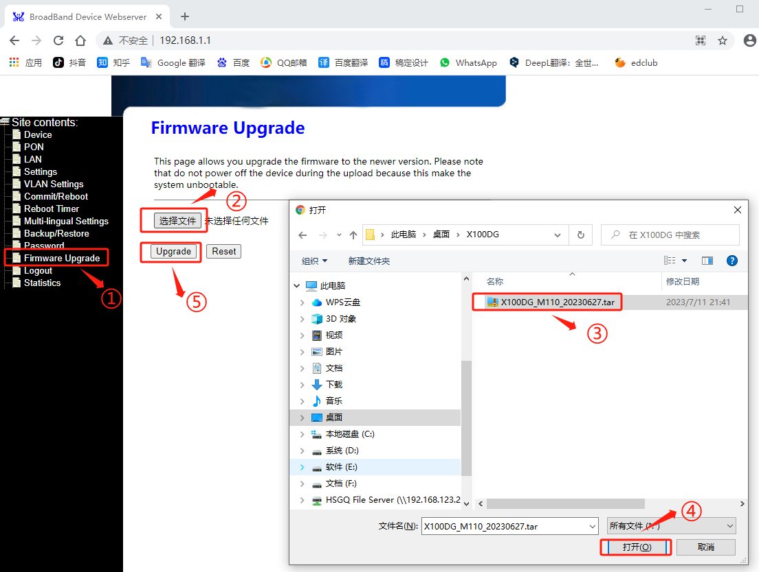
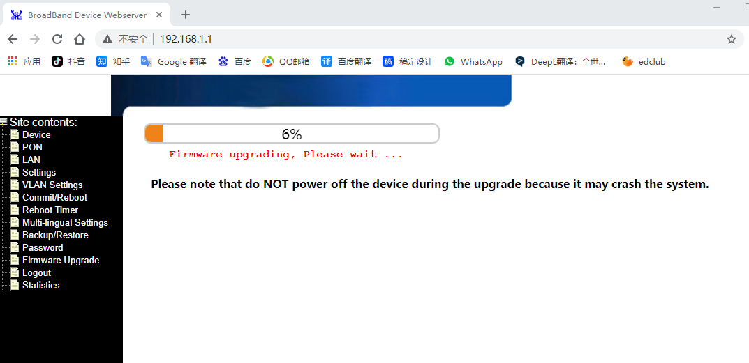

Logout
Log out of the web management page
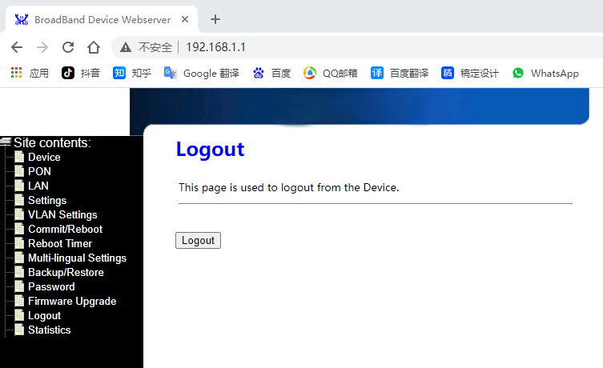

Statistics
The statistics page contains LAN and PON port statistics.
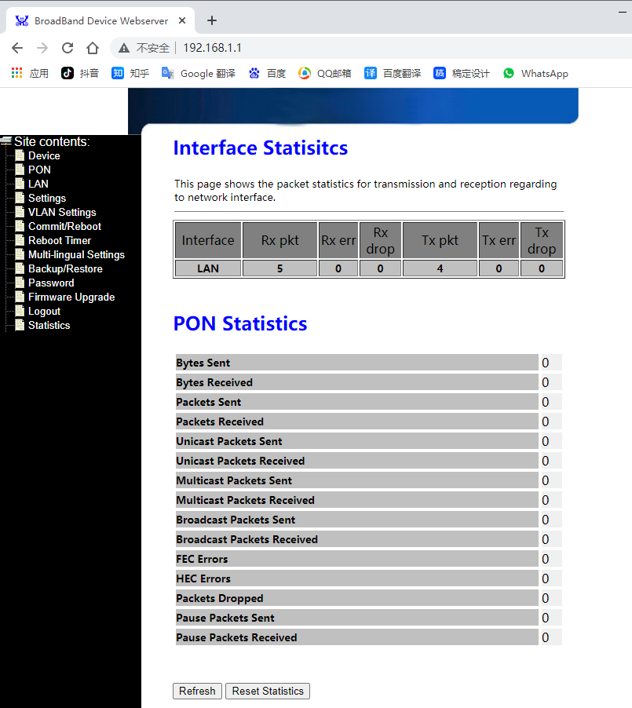

Common Fault Handling

Serial Number | Faultphenomenon | Solution
1 | POWER light does not light up | - Check whether the power access is normal  - Check whether the power switch is on
2 | PON light does not light up | - Check whether the optical fiber is connected normally  - Check whether the ONU has passed the verification
3 | LAN light does not light up | - Check whether the cable is damaged or connected correctly  - Check whether the cable is made incorrectly. Please use a cable made according to the standard Category 5 twisted pair method.  - Whether the length of the network cable exceeds the allowed range

